CREATIVE CHESS EXAMINATION
By

GM Bong Villamayor
Powerchess Asia

The following are selected positions for examination to test players’ level of creativity. Players are reminded to work on the exercises by themselves and write down their solutions clearly.
1/W 2/W
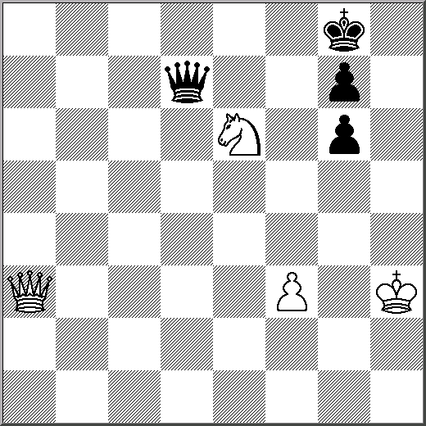
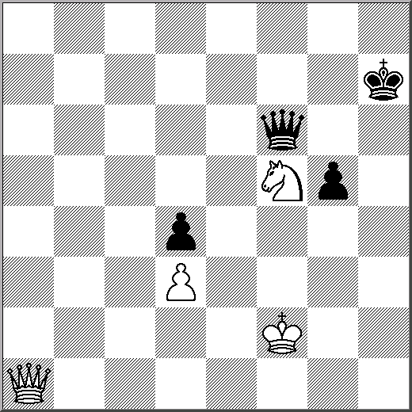

3/W 4/W
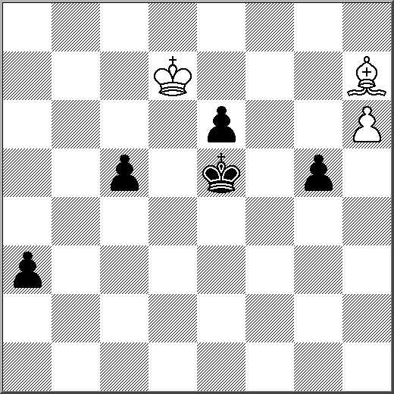
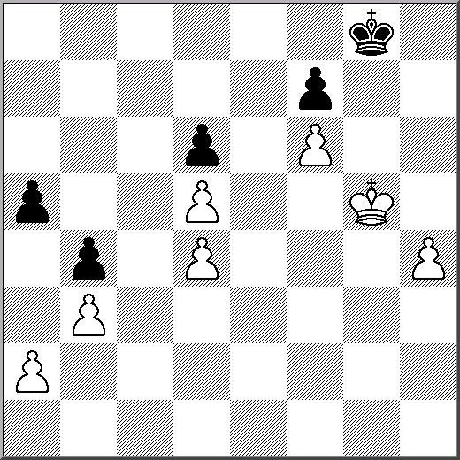

5/W
